1. Given an array of integers, find the pair of adjacent elements that has the largest product and return that product.
2. Given an array of integers. All numbers are unique. Find the count of missing numbers between minimum and maximum elements to make integers sequence.
3. Convert a long phrase to its acronym.

|  |  |
| --- | --- |
| **Input** | **Output** |
| ‘Prisoner of War’ | ‘POW’ |
| ‘Have a good night’ | ‘HAGN’ |

1. Given a string of digits, output all the contiguous substrings of length n in that string.

|  |  |
| --- | --- |
| **Input** | **Output** |
| ‘495215’, 3 | ‘495’, ‘952’, ‘521’, ‘215’ |
| ‘abcdfghz‘, 7 | ‘abcdfgh’, ‘bcdfghz’ |

1. Create a function that builds a tree like object given an array with object which contains *parent* and *id* properties.

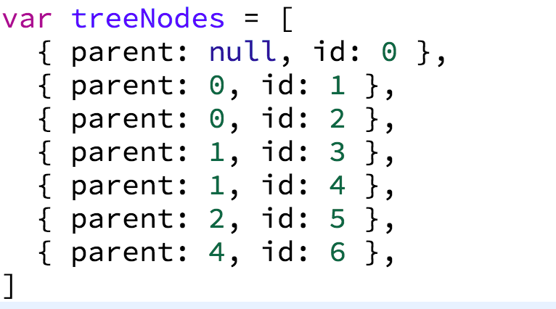 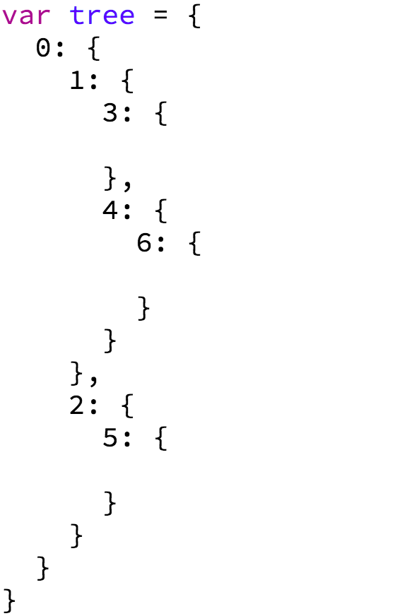

You are given an object like this You should create an object like this: